NAND3 Gate

Test bench
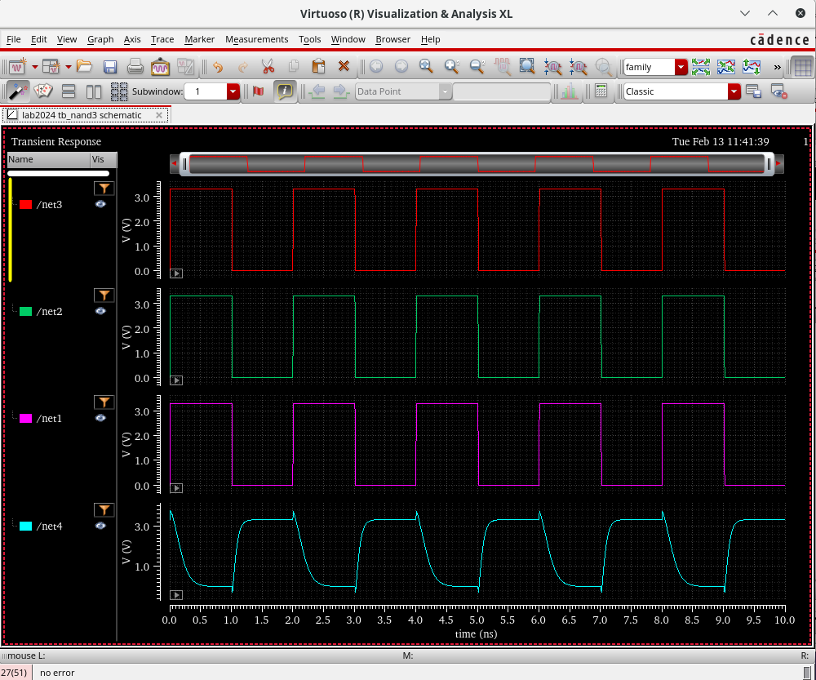
Interpretation of Pins:
Net4: Output
Net3: Input a
Net2: Input b
Net1: Input c

Schematic
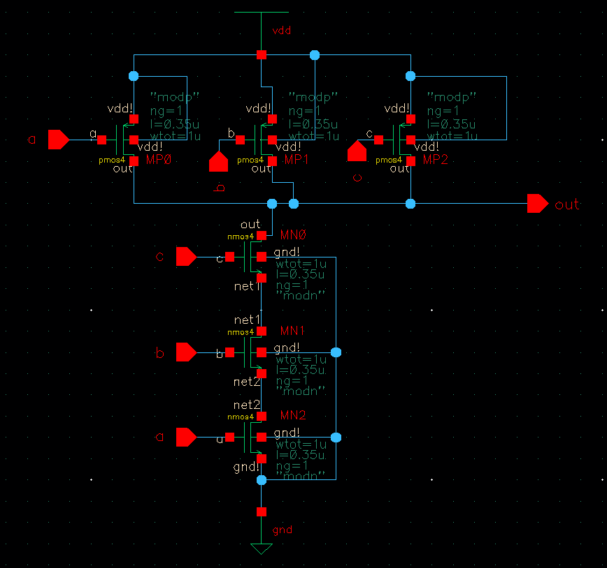

Test bench Schematic

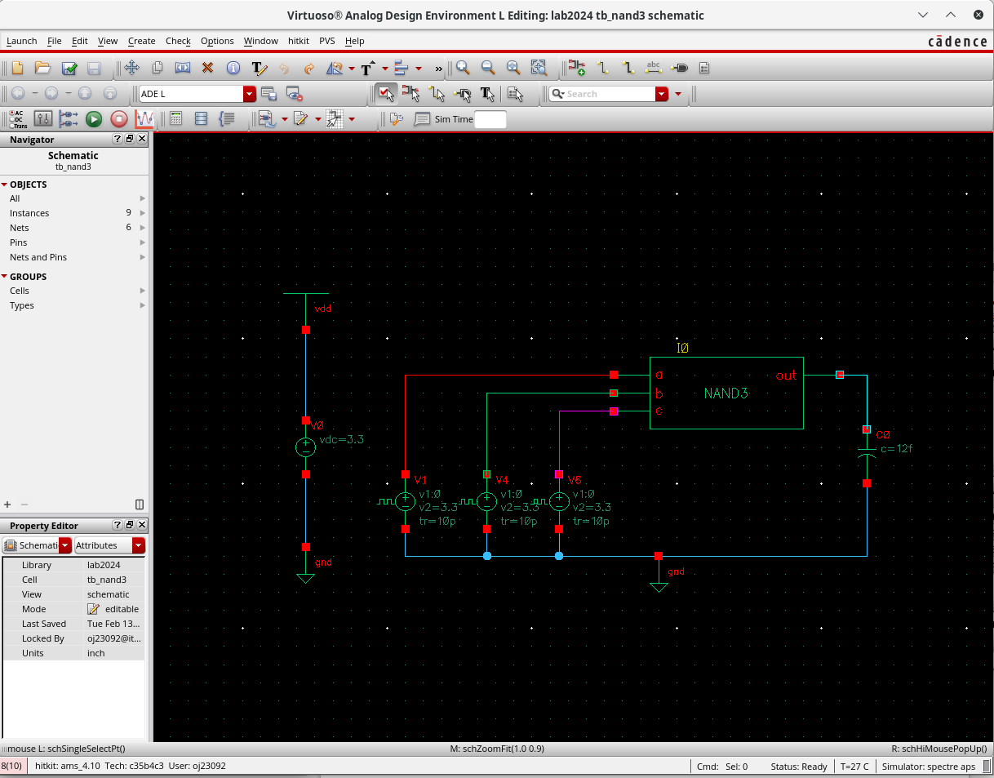
Settings used:

For the Vpulse – 3.3 V and fall and rise time of 10ns.
For the Capacitor – 12f F

Rest of the settings are as seen on image.

Layout
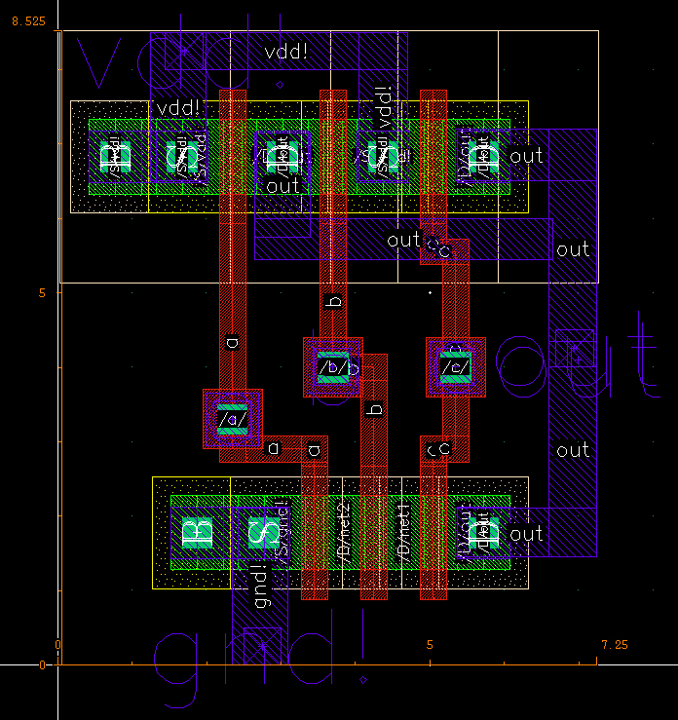

No DRC Errors

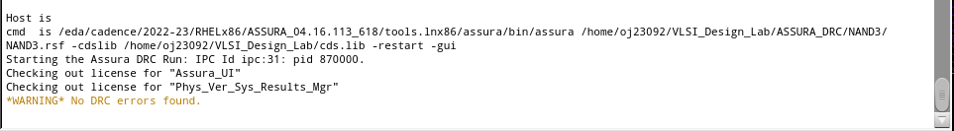

No LVS Errors

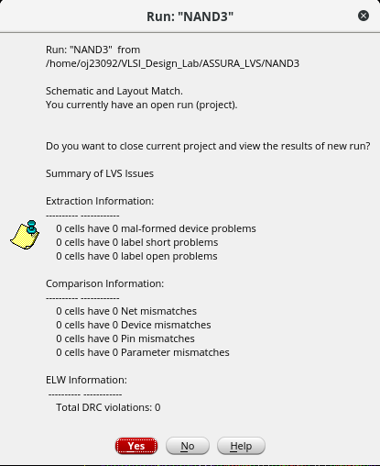

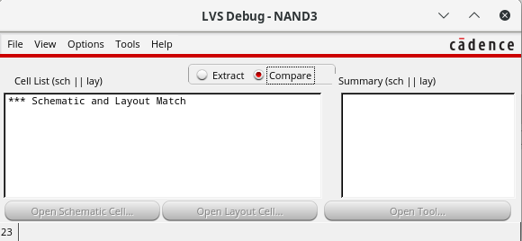

Input and Output Test Waveforms

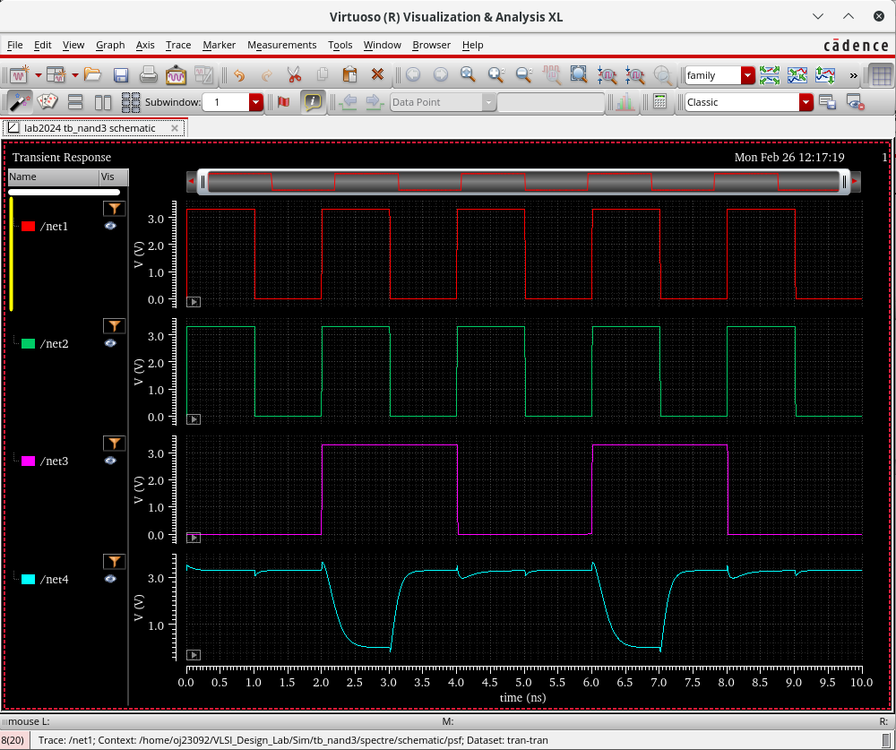

Input a: net3
Input b: net2
Input c: net1
Output: net4

Cell Dimensions

Cell Width: 7.25
Cell Height: 8.525
Cell Area: 61.80625

(Find units)

